Paper Title (Title Case, 14 Bold)

First Author¹*, Second Author ²

¹Department, College/University Name, Country Name
²Department, College/University Name, Country Name

*Author for Correspondence E-mail: mailid@author, Tel:
Abstract
Write your abstract here in 10-point Times New Roman. Limit the abstract within 250 words. The whole manuscript should be limited to 8-10 pages.

Keywords: About five key words separated by comma
INTRODUCTION

INTRODUCTION
Write your introduction section here in 10-point Times New Roman. The introduction part should give the necessary background / motivation behind the work. The citations of others’ work may be bracketed [1-4] appropriately.

LITERATURE REVIEW AND OBJECTIVE
This subsection should contain the literature review and the objective of the work undertaken. Write text matter here in 10-point Times New Roman. Necessary citations may be bracketed [5-8] appropriately.

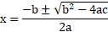 | (1)

MATERIALS AND METHODS
Write your texts here in 10-point Times New Roman. This part should contain the necessary matters related to computational, experimental and analytical investigations. Necessary citations may be bracketed [9, 10] appropriately. All Figures and Tables are to be cited within the text. The Figure/Table captions must be written in Times New Roman 9 point, bold. The Figure caption should appear at the bottom of the Figure, while the Table caption should appear on top of the Table.

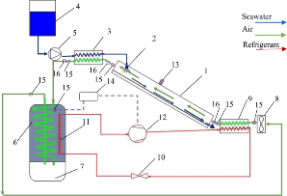
Figure 1: Schematic diagram of the set-up

Table 1: Accuracy of aerodynamic independent variables

Independent Variables | Accuracy
Combined Rotor torque (T_{rotor})
Angular velocity of combined rotor )
(As indicated above, all the notations are to be italicized and be written in 10 Point Times New Roman)

RESULTS AND DISCUSSION
The analysis of results is to be written here in 10-point Times New Roman. All Figures are to be cited within the text. Results obtained may be compared with the published data wherever applicable/possible through necessary citations in bracketed form [11, 12].

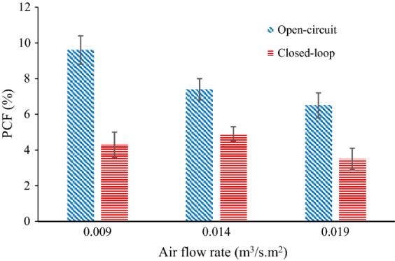
Figure 2: Variation of PCF with air flow rate

CONCLUSIONS
The key findings of the work are to be placed here in 10-point Times New Roman. The conclusion part should be qualitative and quantitative.

NOMENCLATURE
A | Frontal area of rotor | [m²]
AR | Aspect ratio | --
C_{D} | Drag coefficient | --
α | Angle of attack | (ᵒ)
ρ | Density of air | [kg/m³]
ω | Rotor rotational speed | [rad/s]
(As indicated above, all the notations are to be italicized and be written in 10 Point Times New Roman)

REFERENCES
- T. Ogawa, H. Yoshida, and Y. Yokota, Development of Rotational Speed Control Systems for a Savonius-type Wind Turbine, ASME Journal of Fluids Engineering, 111(1), 1989, p. 53.
- C. D. Rakopoulos, and E. G. Giakoumis, Second-Law Analyses Applied to Internal Combustion Engine Operation, Progress in Energy and Combustion Science, 32(1), 2006, pp. 2-47.
- M. Eswaran, Waves Simulation in an Excited Cylindrical Tank Using σ-transformation, Paper No. IMECE2010–39752, ASME International Mechanical Engineering Congress and Exposition, November 12–18, 2010, Vancouver, Canada.
- F. M. White, Fluid Mechanics, McGraw-Hills, New York, USA, 2011.

